|  |  |  |  |
| --- | --- | --- | --- |
| **Document Number** | **HUG3** | | |
| **Document Title** | Assessment Guidelines | | |
| **Department Ownership** | Hand and Upper Limb | | |
| **Document Type** | User Guide | | |
| **Department Owner** | Tim Darch | | |
| **Document Author** | Derrick Chan | | |
| **Last Edited By** | Nick Filevski | **Lasted Edited On** | 02/12/2014 |

# Purpose

The purpose of this User Guide is to assist in performing range of motion testing.

The objective of measuring range of movement is:

1. Provide data regarding the quantity of available AROM and PROM at a specific joint

b) Provide a baseline measurement to monitor changes within the joint over time

# Scope

To any REDiMED staff that carryout range of motion testing.

# Reference Documents

# Definitions

**Indications -** Many factors may affect the outcome of ROM measurements, these include; oedema, pain, adhesions, capsular tightness or laxity, tendon excursion, strength deficits and muscle hypertrophy.

**Administration -** There are various methods of administration which are described below. It is important to be aware that proximal joint posture influences distal joint motion, the position of the elbow, forearm, or wrist should be standardised according to the specific joint being measured.

**Instruments -** There are various sized goniometers. The goniometer size and design should be appropriate to the joint being measured. The circular bodied goniometers allow lateral placement. Half circle goniometers allow for lateral, volar, or dorsal placements.

**Goniometer placements -** The axis of the goniometer should be placed at the axis of the joint being measured, and the arms aligning with the long bones. In most cases, joints are measured on the dorsal aspect. However, in the presence of oedema or severe joint contracture, lateral placement is preferred. Lateral placement may also be indicated if fingernails are curved or have limited contact with the goniometer.

**Frequency of testing -** Formal re-evaluation is dependent on the patient’s diagnosis and acuity of the injury. Acute injuries may be measured on a daily basis to monitor the effects of specific therapeutic intervention, which chronic conditions may only need to be measured monthly.

**Elbow/Forearm:**

**Special considerations**

The arm must remain adducted during testing to avoid substitution of shoulder internal/external rotation for the forearm supination/pronation.

The last method described for measuring supination/pronation should be conducted with caution, as the patient may substitute hand mobility for forearm mobility resulting in incorrectly high measurements.

|  |  |  |  |  |  |  |
| --- | --- | --- | --- | --- | --- | --- |
| Example | Joint | Motion | Starting position | Axis | Stationary arm | Moving arm |
|  | Elbow | Flexion | Standing; shoulder adducted, forearm supinated | Lateral epicondyle of the humerus | Laterally, parallel to the long axis of the humerus on the lateral aspect | Laterally, parallel to the long axis of the radius |
| Elbow | Extension | Standing, shoulder adducted, forearm supinated | Lateral epicondyle of the humerus | Laterally, parallel to the log axis of the humerus on the lateral aspect | Laterally, parallel to the long axis of the radius |
|  | Forearm | Pronation | Seated, shoulder adducted, elbow 90 flexion, forearm neutral, wrist relaxed | Parallel to the long axis of the forearm | Dorsal surface of the distal radius and ulna, perpendicular to the floor | Dorsal surfaces of the distal radius an ulna parallel with the wrist creases |
|  | Forearm | Supination | Seated, shoulder adducted, elbow 90o flexion, forearm neutral, wrist relaxed | Parallel to the long axis of the forearm | Volar surface if the distal radius and ulna, perpendicular to the floor | Volar surface of the distal radius and ulna parallel with the wrist crease |
|  | Forearm | Alternative method to measuring supination/pronation: have the patient hold a pencil in a fisted hand | Seated, shoulder adducted, elbow 90o flexion, forearm neutral, wrist relaxed | Head of the third metacarpal, which coincides with the longitudinal axis of the forearm | Perpendicular to the floor | Parallel to the pencil |

**Wrist:**

|  |  |  |  |  |  |  |
| --- | --- | --- | --- | --- | --- | --- |
| Example | Joint | Motion | Starting position | Axis | Stationary arm | Moving arm |
|  | Wrist | Flexion | Forearm neutral | 60% midcarpal joint, 40% radiocarpal joint | Dorsally, parallel to the longitudinal axis of the radius | Dorsally, parallel to the longitudinal axis of the third metacarpal |
|  | Wrist | Extension | Forearm neutral | 66% radiocarpal joint, 34% midcarpal joint | Volarly, parallel to the longitudinal axis of the radius | Volarly, parallel to the longitudinal axis of the third metacarpal |
|  | Wrist | Radial deviation | Forearm pronated, neutral wrist | Intercarpal joint | Dorsally, parallel to the midline of the forearm | Dorsally, parallel to the midline of the third metacarpal |
|  | Wrist | Ulna deviation | Forearm pronated, neutral wrist | Intercarpal joint | Dorsally, parallel to the midline of the forearm | Dorsally, parallel to the midline of the third metacarpal |

**Thumb:**

|  |  |  |  |  |  |  |
| --- | --- | --- | --- | --- | --- | --- |
| Example | Joint | Motion | Starting position | Axis | Stationary arm | Moving arm |
|  | CMC | Palmar abduction | Wrist neutral | At the intersection of the lines parallel to the first and second metacarpal | Parallel to the second metacarpal along the radial aspect | Parallel to the first metacarpal along the radial aspect |
|  | CMC | Radial abduction | Forearm pronated, wrist in neutral | At the intersection of the lines parallel to the first and second metacarpal | Parallel to the second metacarpal along the dorsal aspect | Parallel to the first metacarpal along the dorsal aspect |
|  | CMC | Opposition | Forearm supinated, wrist in neutral | At the intersection of the lines parallel to the first and second metacarpal | N/A  Use RULER to measure the distance from volar IPJ of thumb to the 3rd MC with thumb nail parallel to the plane of the palm | N/A |
|  | MP | Flexion | Forearm and wrist in neutral | MP joint | Dorsally, parallel to the first metacarpal | Dorsally, parallel to the thumb proximal phalanx |
| MP | Extension | Forearm and wrist in neutral | MP joint | Dorsally, parallel to the first metacarpal | Dorsally, parallel to the thumb proximal phalanx |
|  | IP | Flexion | Forearm and wrist in neutral | IP joint | Dorsally, parallel to the proximal phalanx | Dorsally, parallel to the distal phalanx |
| IP | Extension | Forearm and wrist in neutral | IP joint | Dorsally, parallel to the proximal phalanx | Dorsally, parallel to the distal phalanx |

**Fingers:**

|  |  |  |  |  |  |  |
| --- | --- | --- | --- | --- | --- | --- |
| Example | Joint | Motion | Starting position | Axis | Stationary arm | Moving arm |
|  | MP | Flexion | Wrist and forearm in neutral, IP’s relaxed for PROM, flexed for AROM | MP joint | Dorsally, parallel to the metacarpal | Dorsally, parallel to the proximal phalanx |
| MP | Extension | Wrist and forearm in neutral, IP’s relaxed for PROM, extended for AROM | MP joint | Dorsally, parallel to the metacarpal | Dorsally, parallel to the proximal phalanx |
| MP | Hyperextension | Wrist and forearm in neutral, IP’s relaxed for PROM, extended for AROM | MP joint | Volarly, parallel to the metacarpal | Volarly, parallel to the proximal phalanx |
|  | MP | Abduction/ Adduction | Wrist in neutral, forearm pronation, IP’s extended | MP joint | N/A use a RULER to measure the distance from fingertip to fingertip | N/A |
|  | PIP | Flexion | Wrist and forearm in neutral, MP’s and DIP’s relaxed for PROM, flexed for AROM | PIPJ | Dorsally, parallel to the proximal phalanx | Dorsally, parallel to the middle phalanx |
| PIP | Extension | Wrist and forearm in neutral, MP’s and DIP’s relaxed for PROM, extended for AROM | PIPJ | Dorsally, parallel to the proximal phalanx | Dorsally, parallel to the middle phalanx |
|  | DIP | Flexion | Wrist and forearm in neutral, MP’s and PIP’s relaxed for PROM, flexed for AROM | DIPJ | Dorsally, parallel to the middle phalanx | Dorsally, parallel to the distal phalanx |
| DIP | Extension | Wrist and forearm in neutral, MP’s and PIP’s relaxed for PROM, extended for AROM | DIPJ | Dorsally, parallel to the middle phalanx | Dorsally, parallel to the distal phalanx |

**Assessment of Function:**

(See the attached USB>outcome measure folder)

* **Canadian Occupational Performance Measure (COPM)**
* **Disabilities of the Arm Shoulder and Hand (DASH):** Consists of 30 questions that ask patients to rate their self-perception of their hand function and symptoms
* **Quick DASH:** A shorter version of the DASH
* **Sollermans Test of Hand Grip:** Used to assess patients ability to perform a number of grips commonly used in activities of daily living

**Oedema:**

**Circumferential measurements**

Circumferential measurements can be done by placing a ¼ inch wide tape measure around the circumference of common bony prominences / land marks.

* Interphalangeal joints
* Metacarpal phalangeal joints
* Distal palmar crease
* Wrist crease

**Figure of 8 method**

**Purpose**

To provide therapists with a method to measure patient edema that is easily administered requires little equipment, reliable, valid, and non-time consuming as compared to other

methods.

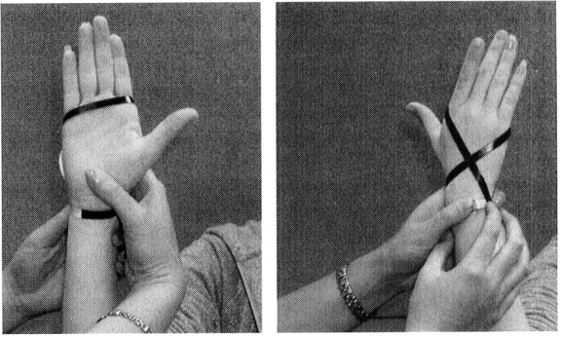

**Psychometric properties**

This method of measuring oedema has a good intra-rater

(0.99) and inter-rater reliability (0.97) (Pellecchia, 2003).

**Administration**

* Patients are seated in an upright position with

their upper extremity supported. The arm is

abducted and externally rotated 90°,

the elbow flexed to 90°, the fingers adducted and

extended and the thumb abducted in the plane

* A ¼-inch wide retractable tape measure is used to make measurements as follows:
* Commence on the radial side of the wrist
* Tape is drawn in an ulnar direction along the wrist passing over the tendon of FCU
* Moved distally and obliquely across the dorsum of the hand passing over the midpoint of the second metacarpal
* Directed ulnarly across the palmar surface with the distal edge aligned with the palmar digital crease of the fifth digit.
* The tape measure continues over the fifth digit being drawn back across the dorsum of the hand crossing over the tendon of the abductor pollicis longus where the distal end of the tape is realigned with the distal crease and directed back to the starting point.

**Informal assessment (descriptive)**

* *Pitting***:** A pit will develop by briefly applying pressure to the swollen region. The pit will slowly refill with fluid. Pitting occurs in the initial stages of oedema when there is excess fluid in the interstitial space.
* *Brawny*: If unresolved pitting oedema becomes brawny / fibrotic. Brawny oedema is firm to the touch and does not pit
* *Skin texture*: Skin becomes shiny / taut when oedema is present with loss of wrinkles or joint creases

**Pain:**

**Subjective Assessment: Visual Analogue Scale**

**Purpose**

Used to determine a patients level of pain. Useful for monitoring patient’s pain levels over a period of time.

**Administration**

* Ask the patient to rate their level of pain from 0 (no pain at all) to 10 (worst pain imaginable). A visual representation such as below can be provided.
* Individual Visual analogue scores can be taken for when a person is :
* At rest
* Performing light ADL’S
* Performing resistive tasks

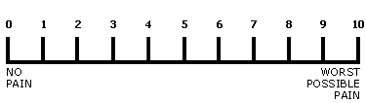

**Neuropathic pain assessment:**

The S-LANSS: The S-LANSS is a simple 7-item instrument for identifying pain of predominantly neuropathic origin. Each item is a binary response (yes or no) to the presence of different symptoms or clinical signs (Refer to appendix for assessment)

**Scar:**

**Informal scar assessment**

**When assessing a scar the following should be considered:**

**Location:** Does the scar cross joints and are deeper structures involved

**Colour:** Scars typically begin as deep red and gradually become lighter

**Types**: Note the type of scar

|  |  |
| --- | --- |
| *Atrophic* | This type of scarring takes the form of a sunken recess in the skin. It is often seen with wounds where skin or muscle is removed by an injury. This type of scarring can also happen when the body  produces so much scar tissue in one area that it prevents news cells from growing where the wound took place |
| *Contracture* | These types of scars often happen with burns, and end up pulling the skin in towards the site of injury. They can make the skin look puckered around the wound |
| *Hypertrophic* | These scars are usually red or purple and are slightly raised above the skin. They tend to fade and become flat over time |
| *Keloid* | Is an excessive amount of collagen which continues to enlarge beyond the original size and shape of the wound |

**Flat/raised:** Immature scars are thick, rigid and raised whereas mature scars are flattened and softened

**Sensibility:** Note if the scarred area is hypersensitive or lacking sensation

**Size:** The length and size of a scar can be measured with a ruler

**Adhesions:** Assessment of adhesions of surface scars to underlying tissue is done by observation and palpation. Some adhesions can be identified when a client is performing active movements. When the adhesion is on the dorsal hand or wrist or the volar wrist/forearm, the scar can be seen to dip deeper or dimple when active movement is performed due to adhesions from the superficial scar to underlying structures (i.e. tendons/fascia). Adhesions of surface scar to underlying tissue can be assessed by palpation. Attempt to slide or lift the scar tissue in a manner that is similar to the surrounding skin and describe the level or adhesion (i.e. mild / moderate / severely adhered)

**Formal assessment: Vancouver Scar Scale:**

**Purpose -** The Vancouver Scar Scale (VSS) is an index used to rate a scar on four different factors, including pigmentation, vascularity, pliability and height.

**Equipment**

* Small metric ruler
* Clear plastic sheet

**Administration -** Evaluate the scar five minutes post the removal of pressure garments with the part acclimated to temperature.

|  |  |  |
| --- | --- | --- |
| **Factor** | **Definition** | **Scale** |
| **Pigmentation** | Both areas of skin are blanched with transparent plastic to eliminate the effect of vascularity. The scar is rated according to predominance of the worst changes present | 0=Normal, closely resembles colour of the rest of the body  1= Hypopigmentation  2= Hyperpigmentation |
| **Vascularity** | In the early phases of wound healing, scars are hyperaemic as a result of increased blood flow. This decreases with maturation. At rest and by blanching, the scar is observed and scored | 0= Colour and capillary refill are normal  1= Pink: slight increase in local blood supply  2= Red: Significant increase in local blood supply  3= Purple: congested, slow refill, incomplete blanching |
| **Pliability** | Functional mobility of the scar as related to the contracture and elastic texture are rated by manipulating normal skin and comparing it to burn scar | 0= Normal  1= Supple: minimal resistance, flexible  2= Yielding: gives way to pressure  3=Firm: moves in a solid, inflexible unit  4= Banding: ropes of scar tissue that do not limit ROM  5= Contracture: shortening of scar producing deformity or decreased ROM |
| **Height** | Related to the overall collagen content of scar and relative oedema of tissue | 0= Normal: flat scars flush with normal tissue  1= 2mm  2= 2-5mm  3= 5mm |

**Grip Strength:**

**Jamar Dynanometer**

**Purpose -** Determining a patient’s grip strength is useful prior to commencing any strengthening program. Testing is contraindicated before full healing.

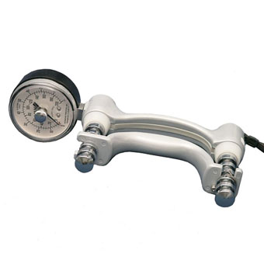

**Administration**

* Set the Jamar hand dynamometer to the second handle

position

* Patient seated with;
  + Shoulder adducted and neutrally rotated
  + Feet flat on the ground
  + Elbow flexed at 90 degrees
  + Forearm and arm in neutral
  + Wrist between 0 and 30 degrees dorsiflexion and 0 – 15 degrees ulnar deviation
* Grip strength should be applied smoothly, without rapid wrenching or jerking motion
* After the individual is positioned properly say “squeeze as hard as you can, harder, harder, relax”
* The mean of 3 trials is recorded
* The mean score of three trials can be compared to normative data (Refer to table 1). Alternatively the mean can be compared to the dominant / non-dominant hand. Typically an individual’s non-dominant hand is 10% weaker than their dominant hand.

**Alternative to regular grip test = Rapid exchange grip test:** The examiner rapidly moves the dynamometer, alternating from the client’s right to left hands, for 10 trials to each hand. This test had been thought to prevent voluntary control of grip strength by the client, making it more challenging for a client to provide less than maximal effort.

**Table 1.** Table 1 Mean and Standard Deviation and Hand Grip Strength in kilograms, for men and women, presented in ascending age groups (Massy-Westropp et al, 2011)

|  |  |  |  |  |  |  |  |
| --- | --- | --- | --- | --- | --- | --- | --- |
| **Men** | | | | **Women** | | | |
| **Age** | **Right** | **Left** | **BMI** | **Age** | **Right** | **Left** | **BMI** |
| 20 to 29 | 47(9.5) | 45(8.8) | 26.4(5.1) | 20 to 29 | 30(7) | 28(6.1) | 25.1(5.8) |
| 30 to 39 | 47(9.7) | 47(9.8) | 28.3(5.2 | 30 to 39 | 31(6.4) | 29(6) | 27.3(6.8) |
| 40 to 49 | 47(9.5) | 45(9.3) | 28.4(4.6) | 40 to 49 | 29(5.7) | 28(5.7) | 27.7(7.7) |
| 50 to 59 | 45(8.4) | 43(8.3) | 28.7(4.3) | 50 to 59 | 28(6.3) | 26(5.7) | 29.1(6.4) |
| 60 to 69 | 40(8.3) | 38(8) | 28.6(4.4) | 60 to 69 | 24(5.3) | 23(5) | 28.1(5.1) |
| 70 + | 33(7.8) | 32(7.5) | 27.2(3.9) | 70 + | 20(5.8) | 19(5.5) | 27(4.7) |

**Pinch Strength:**

**Administration**

* Patient seated with;
  + Shoulder adducted and neutrally rotated
  + Elbow flexed at 90 degrees
  + Forearm and wrist in neutral
  + Wrist between 0 and 30 degrees dorsiflexion
* Pinch strength should be applied smoothly, without rapid wrenching or jerking motion
* The mean/ average of 3 trials is recorded
* Variations in pinch styles
  + **Lateral/Key pinch;** Place the pinch meter between the radial side of the index finger and thumb, and instruct the client to pinch as hard as possible.
  + **Two-point pinch/ Tip pinch;** Place the pinch meter between the tip of the thumb and tip of the index finger, and instruct the client to pinch as hard as possible.
  + **Three point pinch/ Palmar pinch;** Place the pinch meter between the pulp of the index and middle fingers, and instruct the client to pinch as hard as possible.

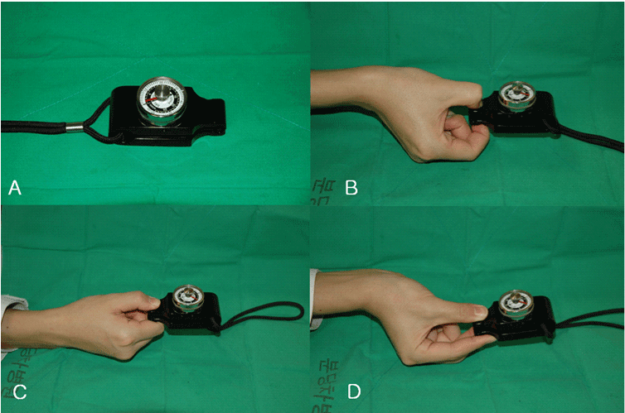

(A) Jamar pinch gauge dynamometer

(B) Tip pinch is thumb to index finger

(C) Key pinch is thumb pad to lateral aspect of middle phalanx of index finger

(D) Tripod pinch is thumb pad to pads of index and middle fingers.

**Manual Muscle Testing:**

**Purpose:** Manual muscle testing allows a therapist to gain insight in to the strength of individual muscle groups. In relation to hand therapy manual muscle testing is useful for determining if motor weakness exists due to a nerve neuropathy or to determine the level of motor recovery of specific muscles following repair or release of a nerve.

Muscle strength grading is as follows:

**Grade 5:** Patient can hold the position against maximum resistance and through complete range of motion

**Grade 4:** Patient can hold the position against strong to moderate resistance, has full range of motion

**Grade 3:** Patient can tolerate no resistance but can perform the movement through the full range of motion

**Grade 2:** Patient has all or partial range of motion in the gravity eliminated position

**Grade 1:** The muscle/muscles can be palpated while the patient is performing the action in the gravity eliminated position

**Grade 0:** No contractile activity can be felt in the gravity eliminated position

*Refer to MMT handout for more information on testing specific upper extremity muscle groups*

**Sensation:**

**Downey Hand Centre Sensibility Test (DHCST)**

**Purpose**

The purpose of the DHCST is to establish a baseline of hypersensitivity in order to develop a desensitisation program for clients who have developed hypersensitivity from various diagnoses i.e. amputations, burns and neuromas.

**Administration**

When conducting the assessment the therapist should not have direct contact or touch with the patient’s limb being tested as it may create an altered perception of texture being used.

The DHSCT requires patients to rate different textures/sensations and is separated in to three sections as follows:

**Dowel Textures**

* Clients vision is occluded
* One of the dowels (a dowel that is wrapped in textures ranging from moleskin to velcro) is randomly selected and tapped or rolled over the hypersensitive area
* The therapist randomly selects a second dowel and follows the same method outlined above then asks the patient to compare it to the first texture to determine which was more irritating to the skin
* This procedure is followed until all 10 dowel textures are lined up and ranked from least irritating to most irritating
* Results are recorded on the initial assessment sheet

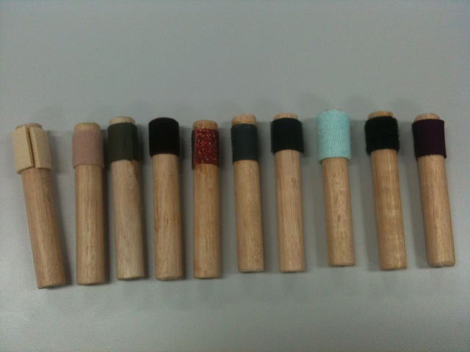

**Immersion Buckets**

* Patients are required to immerse their affected hand in a randomly selected immersion bucket containing particles ranging from cotton wool to small pebbles. The patient should extend and flex their hand or move it around in the buckets
* Similar to the dowel textures all immersion buckets are introduced randomly and rated from least irritating to most irritating
* Results are recorded on the initial assessment sheet

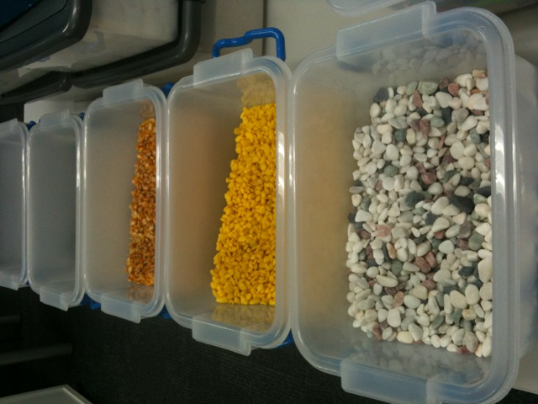

**Vibration:**

* Patients are required to establish a hierarchy of vibration based on a combination of cycles per sec, type of contact (continuous or intermittent application to the affected area) and the amount of time that the vibration applied can be tolerated
* Results are recorded on the initial assessment sheet

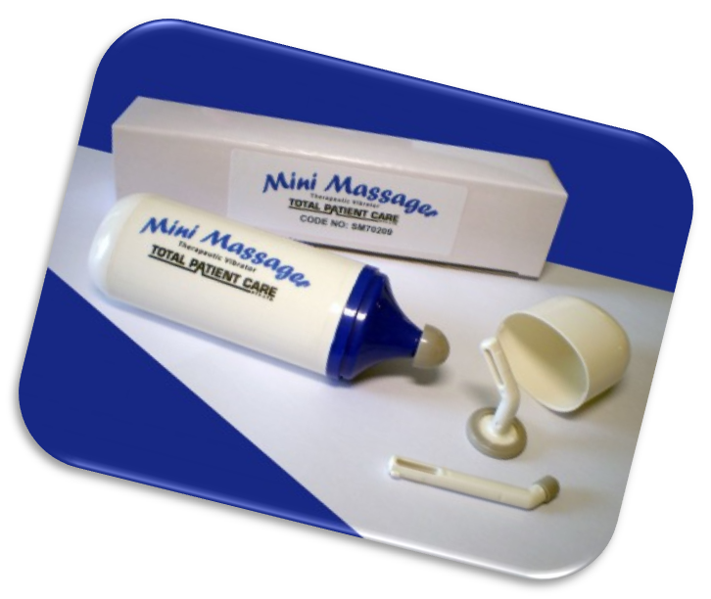

**Note:** If the patient is very hypersensitive they may not be able to tolerate certain textures / vibrations. Therefore the DHCST may need to be completed over a number of weeks as the patients tolerance improves. Refer to appendix for assessment sheet.

**Weber Static Two-Point Discrimination:**

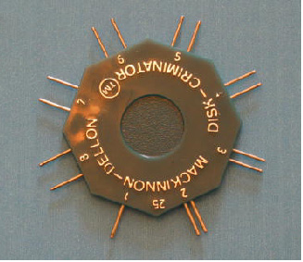

**Purpose**

Determine tactile gnosis

**Administration**

5- 10 minutes

* Vision is occluded
* Support hand or digit to avoid movement of patients

(This would vary the contact force)

* Only flexor zones I and II are tested
* Begin with 5 mm distance between points
* Apply pressure of one or two points just to the point of blanching longitudinally along the finger
* Ask the patient to state whether they feel one or two points on the skin
* Increase the distance or decrease the distance as indicative of the patients response (i.e. progress to 4 if patient can feel two points or decrease to 6 if they state they can not feel two points
* Test is progressed distally to proximally
* Seven out of ten accurate responses are required for distance to be scored. Testing ceases at 15mm if response is inaccurate at that level
* Take comparison measurements of contralateral hand
* Scoring:
* Normal: 0-5 mm
* Fair: 6mm-10mm
* Poor: 11mm-15mm
* Protective: one point perceived
* Anesthetic: no point perceived

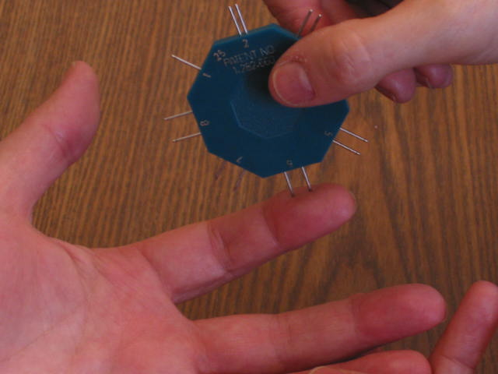

**Semmes Weinstein monofilament testing (mini kit):**

**Purpose**

The Semmes is a discriminative test used to assess the threshold stimulus necessary for perception of light touch to deep pressure. The test is useful for a broad client base including patients who have reduced sensation following nerve laceration or repair or patients who have sensory deficits associated with a nerve neuropathy (i.e. carpal tunnel syndrome). The test can be repeated at different time periods to determine the status of diminishing or returning sensation. The mini kit test consists of five monofilaments that range in diameter. The individual filaments represent the cut-off force for each functional level of sensibility i.e. normal, diminished light touch, diminished protective sensation and loss of protective sensation.

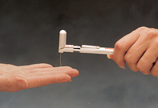

assess the

**Administration**

* The test should be performed in a quiet area
* The patients vision should be occluded
* Prior to testing demonstrate the filament in an area believed to have normal sensation to ensure patient’s understanding of the test
* Filaments are applied individually starting from the smallest in diameter
* The three smallest filaments from 1.65 to 4.08MN (green to purple) are applied **three** times to the same spot in order to ensure that one application reaches threshold. Filaments 4.17 to 6.65 are applied only once.
* Apply sufficient force to cause Filaments 1.65 to 6.45 to bend to exert the specific pressure. Filament 6.65 should be applied to point
* Do not allow the filament to slide across the skin. If necessary repeat the application again
* Each monofilament is applied perpendicular to the skin for 1.5 second intervals (i.e. pressure is applied for 1.5 seconds then removed for 1.5 seconds). The approach, skin contact, and departure of the filament should each be smooth.
* Applications should be randomized so that the patient does not anticipate them
* The patient is instructed to respond by saying “yes” or “touch” when he/she feels a touch or pressure
* Patients are tested with the smallest filament first. If the patient does not respond yes then proceed to larger monofilaments. The therapist may retest any filament if not certain about the response from subject.
* Results can be recorded on the assessment sheets by colouring the area of the hand / upper limb that corresponds with the monofilament colour

**Interpretation of results**

Green 50 mg 2.83 MN = Normal light touch perception

Blue 200mg 3.61 MN = Diminished light touch

Purple 2 g 4.31 MN = Diminished protective sensation

Red 4 g 4.56 MN = Loss of protective sensation

Red/Orange 300 g 6.65 MN

No response = anesthetic

**Wound Assessment:**

**Size:** The length and width of the wound can be measured with a ruler for future comparison. Take care not to touch the wound with the ruler or other measuring devices, unless sterile.

**Depth:** Wound depth may be measured with a sterile cotton swab if the client and therapist are comfortable with this procedure.

**Colour:** Open wounds can be classified as red, yellow, or black. However, many wounds have a combination of these colours.

* Red wound:

The red wound is uninfected, healing according to a predictable schedule, and is characterized by defined boarders, granulation tissue, and apparent revascularization. The wound may be a superficial wound, a second-degree burn, acute fresh wound, a surgical wound, or a wound left open to heal by secondary intention

* Yellow wound:

The colour of a yellow wound can rage from a creamy to a canary yellow. The yellow wound is draining and characterized by slough that is liquid or semiliquid in texture; it contains pus, yellow fibrous debris, or viscous surface exudate. Pink or red granulation tissue usually is seen at the edges of or under the yellow tissue. Yellow wounds are often in the late inflammatory stage or early fibroplasia stage. Yellow tissue may facilitate infection.

*What are the signs and symptoms of a local infection?

* Black wound

The black wound ranges in colour from dark brown to grey-black. The wound is covered in eschar or thick necrotic tissue. Pus may form at the edges because of macrophage activity. New granulation tissue forms under the eschar. Eschar impedes cellular migration and proliferation by acting as a mechanical block and provides a medium in which bacteria can proliferate. The black wound may be in all stages of wound healing

**Drainage:** Drainage may be clear, pink, white, or a yellow colour. Exudate with a yellow colour many indicate infection. Clear, pink or white drainage does not indicate presence of infection.

**Odour:** Odours often indicate infection. Note any odour emanating from the wound, and have the wound assessed by the doctor, nurse or supervisor for potential infection.

**Vascular testing of the hand:**

Blood flow to the hand can be influenced by proximal injury, some conditions and by trauma.

Informal assessment – observation

**Assessment of colour:**

* Increase white **(pallor),** blue **(cyanosis),** or red **(erythema)** coloration of the skin are the most common changes noted

**Assessment of trophic changes** of the skin can provide clues as to the integrity of the vascular system:

* Thinning of the skin
* Disappearance of skin ridges on the volar aspect of the digits
* Thickening of the nail
* Dryness

**Assessment of pain:**

Pain is present in two thirds of clients with upper extremity vascular disease. Pain may be described as aching, cramping, tightness, or cold intolerance.

**Clinical tests:**

**Capillary Refill Test**

* Pressure is placed on the distal portion of the volar finger or over the fingernail of the digit until tissue becomes white
* Capillary refill is then timed as the number of seconds it takes for the colour to return to normal after the pressure is released
* Typically capillary refill time is less than 2 seconds, and the time can be compared with the same digit on the opposite hand or with uninjured digits

**Allen Test**

* 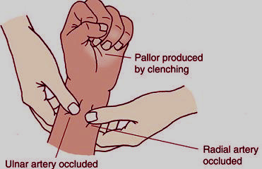Patients hands are held out in front
* The examiner places one hand over the radial and ulnar artery bilaterally
* Patient closes their hand as tightly as possible for one minute (to squeeze blood out of hand)
* Patient then slightly extends their digits while compression of the arteries is maintained
* Note the colour return and the time taken
* If the artery tested is occluded pallor is maintained for a variable amount of time

**Clinical union**

The amount of union of a fracture can be assessed by applying bending, twisting or compression forces to the fracture site to determine the presence or absence of movement. If there is considerable movement at the fracture site it can be seen as well as felt by the patient and examiner. If there is minimal movement it can be felt by the patient in the form of pain. If a patient reports no pain on palpation of the fracture site this is typically a sign that the fracture is clinically stable.

**Ligament stress test**

The valgus stress test measures lateral ligament damage. Ulnar and radial collateral ligaments can be tested on every injured finger. These ligaments can be tested by placing the joint in 30 degrees of flexion and applying a valgus (side to side) force to the finger. Laxity of the ligament should be compared to the contralateral side. If the ligament is lax this is indicative of a partial or complete ligament tear.

**Tinel’s**

Tinel’s is a test used to detect irritated nerves. Tinel’s sign for the median nerve involves percussion over the medial nerve on the volar aspect of the wrist. The test is positive when a tingling sensation occurs in the distal end of the radial three fingers.

